**CHAPTER 3**

**PROJECT METHODOLOGY**

For us to create the system, the utilization and application of a Scrum Agile Methodology in the development of the software will best fit the development cycle of the project. This is in lieu of the multiple different modules that consist of the project software, all of which are sub-deliverable in nature.

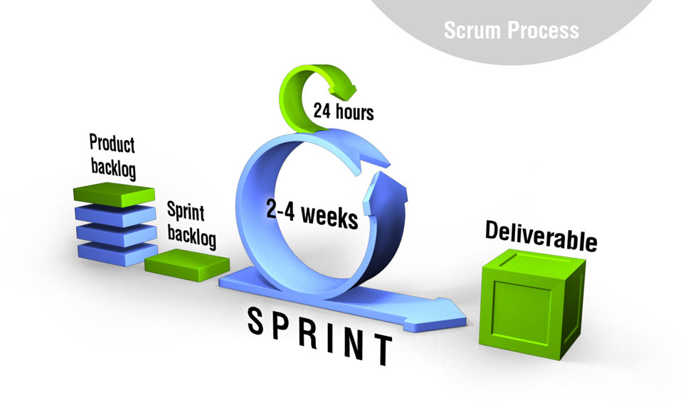

*Figure 3.1 Scrum Methodology Framework*

**3.1 Product Backlog Phase**

During the Product Backlog Phase, the needs, wants, requirements, and specifications for the system software is discussed in full detail between the project team and the client. This gives way for a clear, concise, and defined agreement between the two parties on the expected output of the system project.

By reviewing the complete list of requirements and specifications agreed upon between both parties, and a clear goal has been set for the system project, the entirety of the system project requirements and specifications is then broken down into multiple, specific modules. Each module will provide a project and business value that will support the final completion of the system software. The order and priority level of each module and specification is set by the project clientele to ensure the most important modules get the most attention.

**3.2 Sprint Backlog Phase**

The Sprint Backlog is a collection of multiple, different sprints which contain the many different tasks needed to be accomplished to achieve the system project goal. These sprints contain a number of different tasks for every workhand on the team, each with its own set time to be accomplished, or sprint time.

The team sprints through each sprint backlog to finish their given tasks as soon as possible. A combined effort by the group is done to ensure that each sprint module is accomplished within its given time period, and the team is not allowed to move on to the next sprint without accomplishing every single task on a previous sprint.

**3.3 Daily Scrum Meeting Phase**

A scrum meeting must take place on a daily basis to keep everyone up to speed on the progress of the system project. A scrum master oversees the meeting, where each member in the team gets the chance to speak and update the team on the work he has done so far, any problems he has encountered on his or her given tasks, and any suggestions to improve the overall productivity of the team.

This phase is important in maintaining the atmosphere of the Scrum Methodology, as it acts asan open forum of sorts to bridge ideas among workmates in a given sprint, and solve problems through the combined efforts of everyone in the team.

**3.4 Evaluation of Shippable Product Increment**

After each sprint is accomplished, an evaluation is done on the entire sprint module to verify whether each task in a given sprint has been properly finished with zero problems and an assurance that it lives up to the required specifications. Should any discrepancies be found on any part of the sprint module, it is redone and reworked on to ensure that everything is up to speed before proceeding to the next sprint module.

The client also gets the chance to review and receive a demonstration of the sprint module and what the team has accomplished thus far. Any changes may or may not be made, such as the adding or removing of a certain functionality to meet his or her expectations.

For us to create the system it is imperative to gather data as to how the primitive system works so that we will have a clear view on what needs to be done and the improvements that have to be made prior to the new system.

We, the proponents of this research gathered observable data in the current manner of disseminating information which are through the bulletin boards and have identified the strengths and weaknesses of this medium. Through the guidance of our adviser we thoroughly went through the basic processes that the system will have to do and the features it will contain and additional modules will be added should the need arise. The preliminary design of our system which was the result of our brainstorm proves to be satisfactory but still needs improvement. Designs were made so that we can have an idea as to what the system’s interface would look like. The activity lasted for about a day. The software development model that we will be using is the agile method since we will work in sprints and at each sprint different modules and tasks will be completed as they occur.